Tracy A. Conway
Tracy A. On the Move
Tracy A. Conway Book #5
by Barakah Shakoor
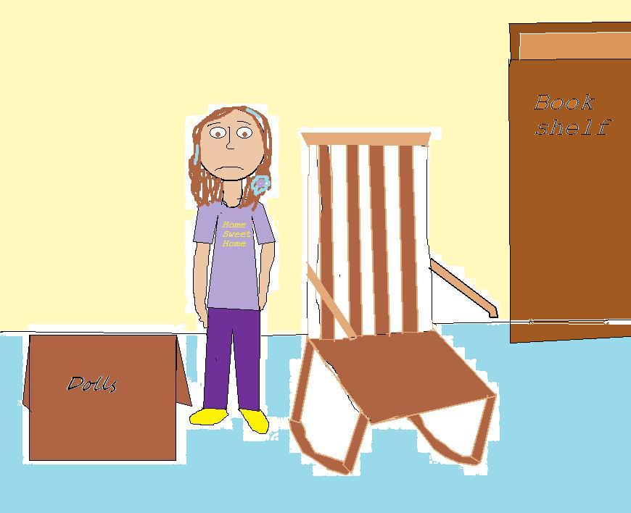
Read the whole series!
Tracy Conway
Tracy Conway and the New Girl
Tracy Conway and the Bicycle Race
Tracy Conway, Real Detective
Tracy A. Moves On
Tracy and Quinn
Tracy A. Conway, Science Fair Maniac

This book is a work of fiction. Any references to historical events, real people, or real locals are used fictitiously. Other names, characters, places, and incidents are the product of the author’s imagination, and any resemblance to actual events or locales or persons, living or dead, (unless publicly known as intended) is entirely coincidental.

Tracy A. On the Move
A LULU PUBLISHING BOOK
First Lulu paperback edition June 2012
Text 2011 Barakah Shakoor
Illustrations 2011 Barakah Shakoor
For more information visit www.lulu.com
Designed by Barakah Shakoor
The text of this book was set in in Comic Sans MS
The illustrations for this book were rendered digitally
Manufactured in the United States of America
This book was written by:
Barakah Shakoor
Tracy A. On the Move / by Barakah Shakoor ; illustrated by Barakah Shakoor
Summary: Ten- year old Tracy A. gets the awful news that she will move to Connecticut, the news that she is getting a new baby brother, and meets a girl named Kelly who helps her with the moving situation.
[1. Tracy—Family—fiction. 2. Moving—fiction. 3. Doctors—fiction.]
More information can be found at:
www.barakahshakoor.wix.com/tracyaconway

For readers like me!

Tracy A. on the Move

Chapter 1: A Note From Yours Truly
Hi. This is Tracy A., writing in her new secret message handwriting. We are in danger. REAL danger. With the oldest, Carla Conway, we might just get out of this dungeon. The queen and king of the house are planning to re-estate ourselves. Even the middle one, Kevin Conway, is in.
ACTUALLY… here’s the translation: For one thing, something I already know is this: When you are about to leave your home that you’ve lived in for 6 years, you have to have a private talk with your mom and dad. Actually, they make it sound like you’re in huge trouble, but the trouble is, you are. You are hearing that you’re going to move. Which is even WORSE than getting in big trouble. You are actually going to M-O-V-E.
STAY TUNED . . .

Chapter 2: A Private Talk
I am currently being normal Tracy A. Conway. Except for one thing. I am actually hearing things. Here I am, in the kitchen, with the living room right next to me. And guess what I’m hearing? My parents and Carla talking. I’m hearing this:
“DAD you CAN’T do that to me! We are TOTALLY NOT doing that! What’s going to happen here when we’re DONE WITH HERE?”
That was Carla. I am not so sure what she meant when she said ‘DONE WITH HERE,’ but I soon found out.
“Carla, you know you moved 4 times before we came here.”
“YES but those OTHER places weren’t as EXCITING as HERE!”
“It’s not going to be that bad. Think about it: You’re going to have a bigger room!”
“For your info, I am not crazy about a bigger room.”
“Anyway, we’ve already planned to move, so that’s what we’re going to do eventually. I’ll talk to Kevin later.”
MOVE? That word spun in my head about one million times.
“But MOM, KEVIN won’t even think that’s a good idea! For your info, he is THIRTEEN and he has A LOT of sports to do and he WILL NOT want to move, you’ll see.”
Actually, Kevin entered the house when Carla said that. He didn’t even take off his muddy shoes and walked into the living room.
“THERE he is. I’M leaving for HIM to TALK to YOU.
Carla stormed out of the living room. I asked, “Are
we going to move?”
“MAYBE,” Carla answered.
“Maybe? I thought that Mom said we were going to,
eventually.”
“Like I said, MAYBE. We still have one month till we move to Connecticut.” My ears perked up.
“CONNECTICUT? You mean like the state me and Abby and Stacy call CONNECT-A-CUT because you have lots of medicine for bruises?” “Yes,” Carla answered.
Just then, Kevin walked calmly out of the living room. Fine, on the contrary. His hair was sticking up and he was actually skateboarded to his room just to show how mad he was. Of course, he fell on the stairs, but I was not in a mood to laugh. Carla said, “What did I TELL YOU?”
Mom said, “Carla, can you please quiet down. Yes, Kevin is mad and sad . . .” blah blah blah.
I kept on repeating the words in my head, and I was sure of two things:
- I was getting dizzy.
- I was dreaming
Because guess what? Kevin was SAD.
Kevin being mad is one thing (I have only seen him be mad 2 times before), and Kevin being sad is another. I have only seen him look sad when Al, his salamander, died. He hasn’t actually experienced the real being sad.
“But MOM! You CAN’T make us move! You can’t! You C-A-N-T!”
I covered my ears and went up to my room. I liked it there. Besides, W-H-Y did we H-A-V-E to move? It didn’t make sense. We already have what we need in this house.
I decided to put this down in my diary (aka journal). But right then and there, Mother came into the room and sat down on my bed. She said, “Tracy, how would you like it if we moved to Connecticut?”
I didn’t answer. I was looking for my diary. “Tracy A.!” My mother said.
“Umm… I wouldn’t like it very much, thank you. I will get back to you on that as soon as I find my journal. See you later.” Then, I noticed something. Was my mom gaining weight or something (don’t laugh). I didn’t think so, because she’s been feeling kind of tired and doesn’t eat a lot of the turkey Dad had made a few days ago. Then I knew. She was going to have a baby! I smiled for half a second but I didn’t say anything. I kept looking for my journal.
My mother left the room after a couple of minutes. Actually, I really wouldn’t like to move. My best friends since kindergarten, Stacy and Abby lived here and I have no idea how I am going to move without wanting to come back again every day to see them and stuff especially on weekends.
I found my journal on my bookshelf. I opened it to a clean page and wrote (with a red pen):
Dear Diary,
My parents say that we’re going to move! To Connecticut! For real! Is that good or bad? Answer me! Where’s my bucket of jokes? I really need to write one down for this situation!!!
I put down my pen and started looking for my bucket of jokes. I found it; a pink bucket with pieces of papers with jokes on them. I started looking for a good joke for my situation; moving.
Then, I found one.
I went back to writing.
Joke for this situation is . . .
What do moving van’s like to do?
Move! (Ha-ha)
Tracy’s response joke:
What does an empty house do when it’s full of cakes?
Gets deserted!
These jokes are so bad. That’s because Abby’s brother, Robert, wrote down some of them, and Stacy’s dad wrote down the others. I have a whole bucket! And I have them for all the situations! It’s so cool.
But still, we are actually moving! I do not know how many sad faces I can take! Also, I have some more news.
MOTHER IS HAVING A BABY!!! SHE REALLY IS! REALLY! REALLY! REALLY! REALLY! REALLY! IT HAS TO BE A GIRL! ACTUALLY, I DON’T CARE IF IT’S A BOY OR NOT, BUT I HOPE IT’S A GIRL! THAT WOULD BE SOOOOOOOOOOO COOL!
Joke for a baby situation:
What did the sister say to the new baby boy?
Oh brother! (Ha-ha this one makes more sense than the moving one!)
Anyway . . . I am starting to think of names for it . . . hmmm…
I picked up my orange rainbow pen and started to write:
Lists of girl names I can think of:
Adrianna I like this!
Anna
Anne
Ella A character in a book!
Pearl This character is in a book I read.
Katherine I like this!
Amy
Julie
Julia
Sarah
Samantha
Amanda
Madeline (aka Madi)
Courtney
Kate
Katie
Mackenzie
Rebecca
Taylor
Emily
Elizabeth
Caroline
Ruby
Alice
Hannah
Danielle ??? Sounds like a boy name but spelled differently…
List of boy names I can think of:
Jordan
George
Mason
Matt
Kyle
Carl

NOTE: I am not in the mood for boy names today. Maybe I’ll add some more of them next time.

I have to go

Stay tuned,
Tracy A. (No need for Conway)
P.S: PLEASE HELP ME WITH THIS MOVING SITUATION! THAT WEIRD JOKE DIDN’T HELP!

Chapter 3: The Battle of Ice Cream and Berries
I put down my pen. I looked outside and I saw Stacy and Abby coming. I ran down the stairs, opened the door, got my helmet, put it on, grabbed my bike and rode up to them.
“Hey,” I said.
“Hey,” they said at the same time.
“What’s going on?”
“Nothing, you?”
“Something.”
“What?”
“We’re M-O-V-I-N-G! In one month!”
“WHAT?” yelled Abby.
“Moving.”
“You’re kidding, right.”
“Nope. I think.”
“You THINK,” said Stacy. “Very interesting.”
“AND, Mom’s having a baby! That’s got to be better!”
“Oh GREAT. It just gets worse,” said Abby.
“What do you mean?” I wrinkled up my forehead.
“He-llo? She’s going to have the baby when you’re moved! That’s how long a baby takes to actually be born.”
“No way! Then you won’t be able to see it! You’re kidding, right?”
“Nope, she’s not,” said Stacy.
“Where are you moving?” asked Abby.
“Connecticut,” I answered.
“Great timing to ask, Abby,” said Stacy.
“Sor-ry! I was just curious, hello?”
“Let’s get off the subject,” I suggested. “Where were you guys going?”
“Creamery. Robert’s going to meet us there, but excuse me, did we invite him?” said Abby. She dug inside her pocket and handed me one five and three ones—dollars.
“Thanks,” I said.
Just then the back door opened and out came . . . Carla. Whew. If it had been Kevin then . . . you wouldn’t want to know. Okay fine, he would just want to come with us.
“Hi,” said me and Stacy and Abby at exactly the same time.
“I’m going to meet Cassie at the Creamery. Wanna come?”
“That’s where we were going,” said Stacy.
“Cool. But too bad for you, Roger’s coming, you know.”
“Just what we needed,” grumbled Stacy.
Roger is one of the most annoying plus mean plus gross plus weird plus you know the rest. And if Robert was there, I knew just what was going to happen.
“Repeat that?” I asked.
“Never mind.”

I ran up the steps right to my home. I burst inside the door.
“HI! I’M HOME!” I yelled and ran right upstairs and jumped on Carla’s bed. Unfortunately, Kevin was there, watching some weird things on the T.V in there, so I got kicked out.
I went into Kevin’s room. Then I lied down on his bed and thought back to what happened. It was crazy. There was an actually food fight, as in F-O-O-D F-I-G-H-T. Seriously.
What happened was:
Even though Roger is just a 6th grader, he can do some 8th grader tough things. Or maybe all of them.
Anyway, once he saw Robert he said, “Hey, Crackle.” (Crackle is Robert’s nickname because he cracks himself up when nobody else is laughing. I am NOTHING like that. Okay fine, maybe SOMETIMES I am).
Robert does not like the name Crackle, and when Roger calls him that, you can just about know what’s going to happen next.
“Hello, Al. Want some of my pistachio?” Roger’s least favorite ice cream is pistachio, and he doesn’t like it when people call him Al. Al is short for his middle name, Alice. And he does not like Alice as a middle name, believe you me. Alice isn’t his REAL middle name. When I was in third grade, he teased me because of my real middle name, Dorothy. He said it stood for Dumb. But then, Kevin gave me the same middle name as his, Alan. Only my family and best friends know what the A. stands for. So then, Roger stopped teasing me because of my middle name. To get him back for teasing me, me and my best friends changed his middle name, Albert, to Alice. Ha-ha.
Roger snatched up the pistachio scoop and let it melt in his hand for a while (eww). Then he tossed it up in the air. “Hey, Crackle look, there’s a bunch of lollipops right there why don’t you go and get ‘em?” Of course, Robert went to get the lollipops. And when he sat back in his chair, he said,
“What happened to my chocolate? It has GREEN all over it!”
And then Roger cracked up and I did, and Stacy and Abby did, and Carla and even Cassie did. You see, Roger gets people to laugh along with him, unlike Robert.
That’s when Robert smashed his cherry and sneaked up behind Roger. Then he put the cherry right on Roger’s nose. He looked like a clown!
Of course, Robert cracked up and only his laugh was heard. You can see how he earned his nickname.
Then, Roger started snorting all over the cherry. And let me tell you, you would want to be in a whole different universe with someone like that snorting on what was once a perfectly good cherry.
Robert could see that his trick wasn’t working, so he gobbled up his ice cream and stuck the cone on Roger’s nose on top of the cherry.
Roger ate it up, of course. And then the real battle came on. Strawberries ruled in the kingdom of red (don’t worry, the red was just strawberry juice, not you-know-what). Roger spilled some crushed Doritos in Robert’s chocolate ice cream (his second cone), making it even worse. Robert aimed for Roger’s eyeball with a strawberry. Then he squirted juice and his aim was totally on it. And THAT’S when I screamed and left the store. I believe Roger is now wiping his red eye.
Cassie ran back home, and Carla called “Wait up!” after me and Stacy and Abby went home too, and I believe that the people who work at the Creamery will be extremely mad at Roger and Robert because he was watching the whole thing. AND he has a LOT of cleaning up to do.
And you know why we ran out? And screamed? Because strawberry juice in the eye is worse that a karate kick in the jaw (don’t worry, I don’t think there’s a such thing. Or maybe I didn’t even have to mention that). You might be not able to see if you have strawberry juice in the eye. And even though Roger is my worst enemy, you can just sit there looking happy when somebody has strawberry juice in their eye.
That’s the end.
I got up and looked all dizzy. Carla came in. “What happened?” I asked. “Did Roger have to go to the eye examination place or something?” “I don’t know. I didn’t see the whole thing,” answered Carla. I sighed.
“Hello? You shouldn’t be happy if someone—”
“I KNOW! I’m not, okay?”
“Okay,” said Carla. Just then the doorbell rang.

The Four E-Ys

Stacy, and Abby were at the door. Then we were all talking at once.
“What in the world was” “I can’t believe” “That was the beginning of battle” “Flying food was” “Wow”
“QUIET!” I yelled. Stacy and Abby stopped talking. “Can we do something that will make us forget about that? How about our webpage? Let’s work on The Three E-Ys.” (You pronounce it The Three Eyes.)
“Okay,” said Abby with a tremendous sigh (of relief, of course). I could tell that she couldn’t stand what happened either.
We went to Carla’s room and asked if we could use her laptop. “An hour ONLY,” she said.
That’s what’s best about Carla. She makes it seem like an hour is a small amount of time. Which it isn’t. She knows that but she wants to be cool-ish.
The Three E-Ys is the name of our webpage. It has our names on it. Except for Mom didn’t want us to use our real names, so we put an E before each Y of our name. So Abby was Abbey, Stacy was Stacey, and I was Tracey. And those names are real, too. That’s what’s so cool about it.
We edited the About Us page and wrote this:
Hello. We’re Tracey, Stacey, and Abbey, the Three E-Ys. You can see why we’re called the Three E-Ys. We love to do the same things; hiking, baking, cycling, running, styling, dressing up, and lots of other things. But the most recent thing that’s happened to us is this:
You must have heard of this guy named Jordan. (We’re using the name Jordan because we don’t want anyone’s name to be their real name. In this case, Jordan is Roger). And you must have heard of someone named Allen. Well, they’re rivals, let us tell you. And they started a big food fight. Eventually, it ended, but Jordan has this big problem. We won’t tell you until we see that he gets better. Stay tuned, fellow contestants,
The Three E-Ys,
Tracey, Stacey, and Abbey
When we finished, I thought about the fact that when I moved, we wouldn’t be able to do the editing together. We would have to send emails (fat chance, Mom won’t let me have an email and neither Carla nor Mom with let me use their email), or write letters. I guess we’ll have to write letters, but it’s going to take FOREVER to get the letter to their mailbox. And I mean forever.
Then, we edited the Photo Gallery and put in some new photos of random things that we took pictures of. We played the Photo Game.
Here’s how you play:
You blindfold someone while they hold a camera. Then that person has to take 5 pictures of different things, like her/his friends, pets, backyard, sock, or something. Yes, even a sock. But they can’t see the sock that they’re about to take a picture of.
Then you blindfold someone else and they do the same thing. You can blindfold as many people as you want to, and you can even have a bunch of different blindfolds and blindfold everyone all at once.
The one, two, three, four or five pictures that look the best are the winner. The person who took the most of the best pictures is also the winner.
So we played that game, and these are the four pictures we put on the photo gallery;
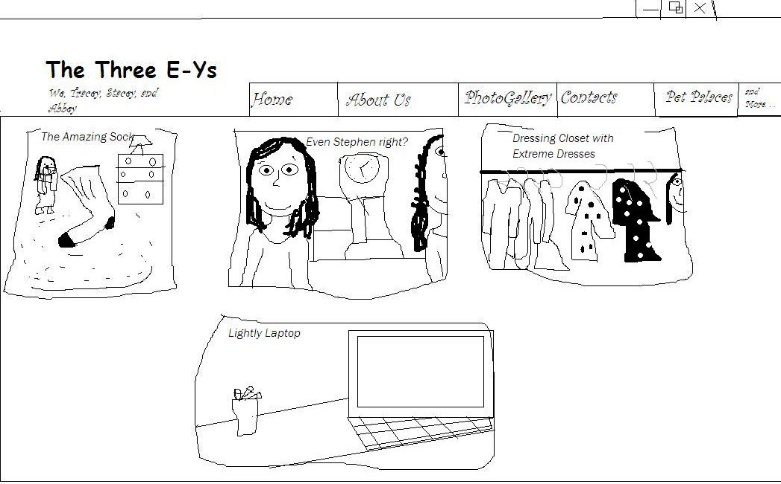

Just then, Mother called and said, “Tracy, please help with the packing!”
“Just a second, Mom! We need a new video!”
Abby held the camera and took a video while Stacey and I played Charades. When we were done playing, we took the video and put it on the website.
Then, I said bye to Stacy and Abby, and went to my room to write in my diary.
Dear Diary,
Me and my friends worked on The Three E-Ys. We did tons of changes. Except for guess what? I won’t be able to do all that once we move next month. No offense.
And guess what else? A HORRIBLE INCIDENT. I am N-O-T, NOT kidding. For real. Roger got strawberry juice in his eye. Seriously. Not to mention Robert did that. Just thinking about it makes me queasy. Hold on a second . . . I’m noxious.
Please stand by . . .
Okay, back. I stopped writing just in time to NOT get puke on my bed. Anyway, I NEED TO DO SOMETHING. WE CAN’T MOVE. I AM NOT KIDDING. I, Tracy D. Conway(the A (Alan) is the middle name Kevin gave me—it’s his middle name, my real middle name is Dorothy. I even like the middle name Alan, so I kept it, except I like it better when it’s just A.), editor of The Three E-Ys, cannot believe what is actually going to happen. Who will buy this house?
In answer to my question, the doorbell rings. I put down my pen an rushed down stairs to see who it was.
And guess who I saw? A girl that was about my age. I heard my mom say to me, “Tracy, this is Kelly Walton, and she is 10 years old just like you. She and her parents will buy this house, isn’t that nice? You two can be friends until we move!”
I groaned. To groan or not to groan, that is the question. “Hi,” said Kelly softly.
“Hi,” I said back. I wrinkled my nose slightly.
“You don’t what to move, do you?”
“Nope,” I said. “So, where did you move here from?”
“California,” answered Kelly. “And I felt just like you do. I still do.”
“Oh,” I said. “California . . .” Then an idea popped right into my head. “How do you spell your name?”
“K-E-L-L-Y. Why?”
“PERFECT!” I jumped up about twenty feet in the air. “You can be part of The Three E-Ys!”
“The Three Eyes?”
“No, The Three E-Ys. E and Y. We have a website called The Three E-Ys, and Mom doesn’t want us to use our real names. I have two other friends, Stacy and Abby, and both of their names end with a Y, no E. So we decided to put an E before the Y of our name. And your name is perfect! Do you want to pert of The Three E-Ys? Your name could be Kelley as in K-E-L-L-E-Y!”
“Sure! I’ll ask! MOM, DAD! Can I be a Fourth E-Y?!” Kelly told them all about it. And guess what? Mr. and Mrs. Walton said, “Sure, Kelly. If it’s okay with Mr. and Mrs. Conway!” I was about to point out that just call them Tracy’s mom and dad, but Mom (aka Mrs. Conway) stopped me and said, “Sure, why not?”
So Kelly got to stay for a while at our house (soon to be hers). I took her upstairs and we changed the name of our website from The Three E-Ys to The Four E-Ys. It was very exciting. I called Abby and Stacy to come over after we were done, much better than our first one. We could use our imagination!
“So,” said Stacy after we were done. Want to hang out at the playground?
“Sure,” everyone said at exactly the same time, including Stacy (answering herself).
When we were at the playground, who did we see but Roger A. Hansson. Brrr. He had a patch over his left eyeball. Ouch.
“Are you okay?” everyone asked at the same time.
“N-O,” he answered. “I’m a pirate. Pirate’s aren’t okay.” Apparently, he didn’t like being bothered at that moment.
“Okay . . .” said Abby. We backed away.
“Wait,” he yelled. “Wanna see my left eyeball? I can show you. Half of it is real pink.”
“Thanks, but . . . no—” But just when Stacy got that far, Roger ripped of his patch. And ooh oh no, it was the most horrible site. I’m not telling. Other than part of his eyelid was peeled off. And his eye was kind of red. That’s basically it. Or maybe I shouldn’t have mentioned that. Was that a better idea? I think so . . .

Chapter 5: Sad Man and Gummy Worms
As we made our way back home, Kelly asked, “What was HE doing? What happened?”
I explained what happened, and everyone was going “Ouch,” and “Brr,” and “Hiss,” and “Quit talking.” So I did.
When we got back to my house, Kelly asked, “Why don’t we play a game of Sad Man?”
“Sad Man?” Me, Abby and Stacy said at the same time.
“Sad Man. Me and my best friend Rhiannon played it when we lived in California. It’s like Hangman. Except it’s got to be something sad. Everything can be something sad, you just have to think about it in a sad way.”
“Alright. Let’s play. Just to get Roger out of my mind,” said Abby.
“Okay!” said Kelley. We played Train, Train, Number Nine to see who got to write down the word.
“Train, train, number 9, coming down Chicago line, if the train should jump the track, do you want your money back? Yes, no, or maybe so?”
“Yes!”
“ Y-E-S spells yes, and you are it!”

I was it. I thought of a word very quickly.
I wrote down on my whiteboard: _ _ _ _ _ _ _ _ _ _ _.
Abby guesses the letter A. She always does. But, too bad, it wasn’t in the word. The board looked like this:

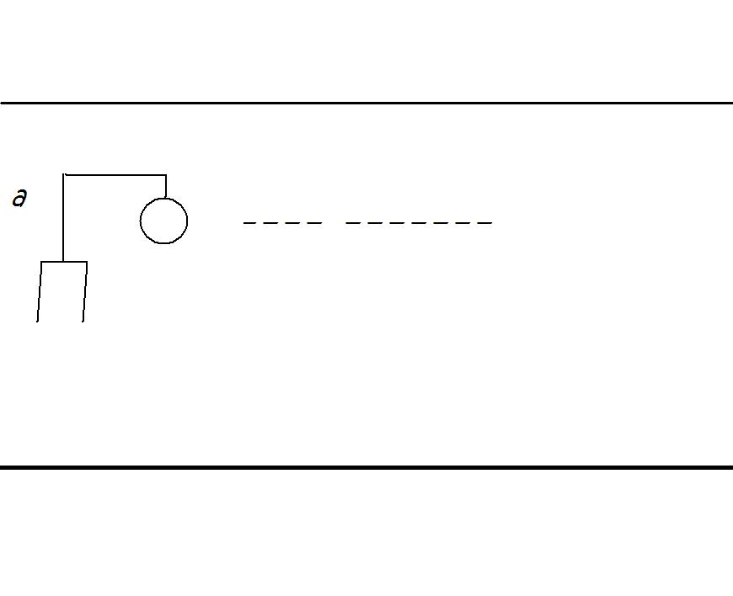

Stacy tried E. It was in. Kelly tried I. It was also in. Abby tried U. It was out. “Two wrong letters in a row! Nightmare already!” Abby groaned. We laughed. The board looked like this:
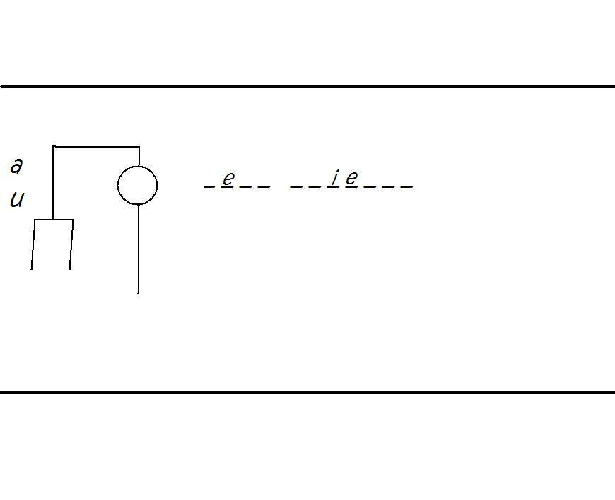
D, B, S, and R were in. W, O, and P were out.

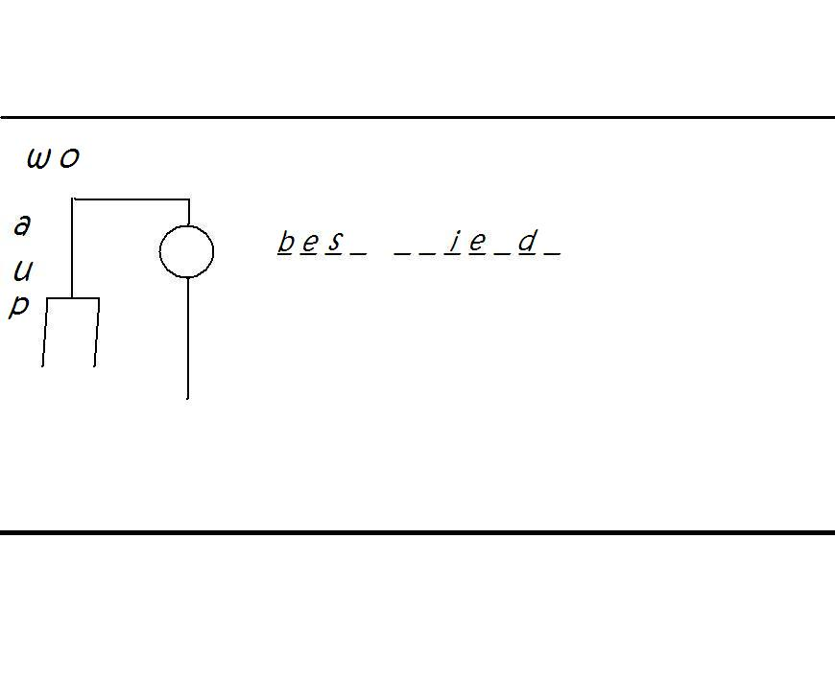
Then, Stacy guessed what the word was. And she got it right!
What did Stacy guess?

“Best friends!” Stacy yelled out.
“Yup,” I said.
Abby said, “I know how best friends are sad. When you move away from them. Like to Connecticut.” She sighed.
“Good job, Stacy,” said Kelly, trying to get us off of the sad subject.
“Thanks. And I’m hungry. Want to have some of our gummy worm collection?” Stacy asked Kelly.
“No thanks. I have my own.”
“Really?” we asked at exactly the same time.
“Really. Me and Rhiannon collected them back in California.”
“Cool!” I said. “I left my gummy worm collection at Abby’s house. Let’s race to our house, get our gummy worm collection, and race back here! First one back wins!”
“You’re on!”
We walked out the front door and got in running position. “Ready! Set! GO!” Kelly yelled and I took off along with Abby.
I already knew Stacy would win. She’s the best girl athlete in our school.
I ran with Abby and passed her. It’s not my fault. She tripped over her surprisingly large shoes.
Perfect. I tripped over my surprisingly tiny shoes. Don’t laugh. They are pretty small.
Another great thing: When I got up I had grass stains on my jeans. Best thing that ever happened to me so far. Not.
I got up and caught up with Abby who was only seventeen feet away from me. At her house. Coming out with gummy worms. I ran inside her house and zoomed past Robert. I wish he weren’t there. He reminded me of the Roger and Robert accident.
I went into Abby’s room and found Mrs. Bartley sitting down on her bed. “Hello, Tracy,” she said. She’s hiding her British accent much better now. I smiled. I found my gummy worms and raced outside. Abby was far out of site. Besides, I was breathing hard.
But I had to catch up. I ran out on the sidewalk. Except I totally forgot that Roger’s house was right next to Abby’s. He walked out and I almost bumped into him. Except for guess what? He didn’t have a patch over his eye anymore! And it was fine!
“Hi,” I mumbled. “Nice eyeball.”
“Hi,” he mumbled back. Then he yelled, “I got you SO good! I mean WE! You know that so called “strawberry?” In my eye? It was a laser! A LASER! We got you guys SO good!” I believe he meant “We got you girls so bad.” But he still had more to say. “Oh and, um, MOM’S BECOMING A DOCTOR! At the Doctor Place. Or whatever it’s called.”
But anyways, LASERS? That realistic strawberry juice was a LASER? I KNEW it couldn’t have been strawberry juice since Roger’s eye “healed” so fast! I am SO going to get him!
I rushed back to my house. Of course, Abby, Kelly, and Stacy were already there.

Chapter 6: News, News, and More News!
“Hey you guys!” I called! “I have some news! I don’t know if it’s good or bad! But—”
“We have some news too!” said Kelly. “Stacy won the race!”
“I don’t care who won! You have to hear this: Roger and Robert were actually working together to trick us! You know, with the strawberry juice? It was actually a LASER! A laser I—”
“I knew he was up to something!” said Abby. “It’s bad news, by the way!”
“Bad news?” said Stacy. “GOOD NEWS. This gives us a perfectly good reason to get Roger and Robert back!”
“HOW?” Me, Kelly, and Abby asked.
Just then, Kevin called me. “Trace, we have some UNEXPECTED news! Kidding, we don’t. NOT! WE GET TO STAY!”
“What?” I asked. What did he mean?
“WE GET TO STAY HERE. In Pennsylvania! NO MOVING! Dad didn’t get the job! WE GET TO STAY!”
“I am NOT falling for another joke,” I said.
“IT’S NOT A JOKE! I’LL PROVE IT! JUST GO TO MOM!”
Him being thirteen and me being ten isn’t a big advantage. Sometimes.
I went into the house and found Mother sipping coffee at the kitchen table. “Mom! Are we moving or not?”
“I know it’s sad, Tracy. But—”
“WHAT ARE YOU TALKING ABOUT, SAD? We get to STAY! Yipee! Zip, zap, and BOOM!”
“Trace, the sad part is . . . your father didn’t get his job.”
“Oh. But he already has a job!”
“Not a real one.”
“Oh. Well, Roger’s mom is becoming a doctor at the Doctor Place and—”
“There’s a doctor place near here? That sounds like a good job. You know . . . your father wanted to get a job in Connecticut . . .”
“Because of all the doctors! They get lots of money, right?”
“Yes. Now, let me talk to Mrs. Hansson to see if she can help with this job search.”
She pushed in some buttons on the phone. I went outside and jumped up and down and so did my friends. We got to stay together! Then, Stacy, who always gets brilliant ideas, got a brilliant idea to scare Roger off.

But I still had one question in my head: Was Kelly still going to stay since we’d still live here?

Chapter 7: The Roger and Robert Trick
I asked Mom this question. And she said, “The Hanssons are moving out of their home, and I’ve already talked to Mrs. Walton and she says that they’ll buy the Hanssons place instead. Then your father will move close to Stacy’s since that’s closer to where your father will work.”
Roger moving! Finally what I wanted! But then I asked, “Wait, is Dad going to live somewhere else? And did he get the doctor job already?”
“No, it couldn’t happen that fast. When we move close to that doctor place, he can ‘practice’ being a doctor and then maybe he actually will. And no, he will ‘live’ with us on the weekends and maybe someday of the weekdays. The house that he’d stay in he’d rent, but if he got the job, he’ll buy the house and all of us will stay there.”
“ALRIGHT!” I had absolutely no problem with moving close to Stacy’s. Now we’ll be closer together!
I ran back outside to tell everyone the news. We cheered and clapped and jumped all around again. Then we continued working on our plan to get Roger and Robert before Roger moved. And, as usual, Stacy had the answer.
We went back into my house, got on the computer (we asked Carla, of course), and edited our webpage. We changed the About Us page to this:

Hello. We’re Tracey, Stacey, and Abbey, the Three E-Ys. You can see why we’re called the Three E-Ys. We love to do the same things; hiking, baking, cycling, running, styling, dressing up, and lots of other things. But the most recent thing that’s happened to us is this:
There’s this person named Roger. And there’s this person named Robert. Roger is afraid of his older sister. And Robert is kind of afraid of Roger, who’s two years younger than he is. Well, Robert got strawberry juice into Roger’s eye. But that’s not it.
It was actually a laser meant to look like strawberry juice. Vote in the comment box. Is that a good trick or a bad one?

The Three E-Ys,
Tracey, Stacey, and Abbey

Then, WE voted, pretending to be lots of other people. We made it seem like only two out of eleven people said that the trick was good. Then, we printed out two posters that looked like this:

Hello there!
We’re here to ask if you’re interested in goofy websites. Only you and one your neighbor next door have gotten these posters. Please visit The Four E-Ys website, and check out every feature. We hope you enjoy it!

The Four E-Ys

We rode our bikes and rang the doorbell to Abby’s house. Mrs. Bartley answered the door. We asked for Robert.
“Robert! Somebody’s here for you!” Mrs. Bartley called.
Robert came and grabbed the poster that Kelly was holding. Then he shut the door. I heard some yelling from Mrs. Bartley about not greeting us, but who cares. We didn’t come for greetings. Then, Kelly went over to Roger’s house. We did better there.
This time Roger himself opened the door, said “Hi,” and took the poster and slammed the door. Except for the slamming door part, the rest was okay. Mysteriously.
Abby cleared her throat. “Ahem. I have to go home now.”
“Okay,” said Kelly. “Let’s hope Robert doesn’t get outraged when he check out the website!”
We laughed. But Kelly was right. Along with Roger and Robert, we needed to watch out for what was coming.

Chapter 8: Kelly on the Move & the Sneaky Trick
“So,” I said after Abby left. “Kelly, can I ask a question?”
“Shoot,” she said.
“Where do you stay until you move into the Hanssons place?”
“There’s a hotel that we stay in. Me and Jane and Mom and Dad. Jane’s getting pretty annoying. She’s thirteen. When I always tell my friends that she thirteen, she always says—”
“More specifically, thirteen and a HALF,” said a voice that came out from absolutely nowhere. We looked around, and then I saw a tall girl with three bracelets on each of her arms, braces, earrings, and long, curly hair.
“That’s Jane for you,” whispered Kelly.
So Jane was here. “How did YOU get here?” asked Kelly?
Jane said, “Dad wanted me to check out the house. Bye.” She walked back into the house. We hear her say, “This is perfect for where we’ll stay, Mrs. Hansson! I’m sorry next week you’ll have to leave here!” She definitely sounded sweeter to Mrs. Hansson.
“Well THAT was quick,” I said.
“I know, right?” Kelly answered. I hadn’t realized Stacy was quiet the whole time.
I said, “Well, there goes your wish for having an older sister, huh?”
“Yeah, probably,” she said. “I didn’t know they could be that . . . you know . . .”
“Insane?” Kelly asked.
“Yeah. We’re all sane. She’s . . . insane,” said Stacy, quoting what Jamie had said to Claudia in the book From the Mixed-up Files of Mrs. Basil E. Frankweiler.
When I got home that evening, Dad was there. And there was chocolate cake. Mom told me that we were celebrating that Dad had a chance to get a great job. I wondered why we just couldn’t have made a party when—I mean if he got the job. I didn’t care about that.

I cared about the chocolate cake.

That’s the first step for I, Tracy A. Conway, to move on.

Chapter 7: The Ending Passage
Well, that’s all for today. I guess we didn’t re-estate ourselves at all. And Dad is trying to get the same type of job Roger’s mom got! The doctor one! And Stacy’s trick for Roger and Robert worked! They stopped bugging us for most of the time!
Stay tuned for the next book: Tracy and Quinn.
All for one and one for all
We’re now five best friends.

Psst… Visit the Tracy A. Conway website for:
- More books!
- More contests-maybe you could get your name in the book next!
- Meet your favorite characters!
- Take the quiz!
- Send a text message to Tracy!
- And way more!
All on www.barakahshakoor.wix.com/tracyaconway

If you are reading this book on the computer, you may buy the book when it gets published. Watch out for the announcement on the link above, or, search for it on www.lulu.com.
Thanks for reading!

Check it out! There’s the first
Official Tracy A. Conway, Volume 1, Books 1-3 Book! Visit www.lulu.com to buy!
