Tracy A. Conway
Tracy Conway, Real Detective
Tracy A. Conway Book #4
by Barakah Shakoor

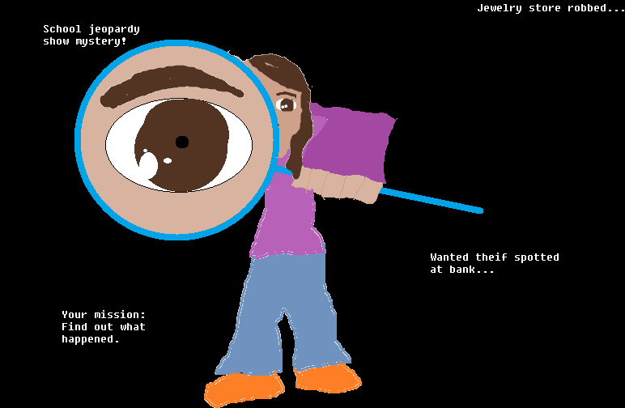

Read the whole series!
Tracy Conway
Tracy Conway and the New Girl
Tracy Conway and the Bicycle Race
Tracy Conway, Real Detective
Tracy A. Moves On
Tracy and Quinn
Tracy A. Conway, Science Fair Maniac

This book is a work of fiction. Any references to historical events, real people, or real locals are used fictitiously. Other names, characters, places, and incidents are the product of the author’s imagination, and any resemblance to actual events or locales or persons, living or dead, (unless publicly known as intended) is entirely coincidental.

Tracy Conway, Real Detective
A LULU PUBLISHING BOOK
First Lulu paperback edition June 2011
Text 2011 Barakah Shakoor
Illustrations 2011 Barakah Shakoor
For more information visit www.lulu.com
Designed by Barakah Shakoor
The text of this book was set in in Comic Sans MS
The illustrations for this book were rendered digitally
Manufactured in the United States of America
This book was written by:
Barakah Shakoor
Tracy Conway, Real Detetcive / by Barakah Shakoor ; illustrated by Barakah Shakoor
Summary: Ten-year old Tracy A. Conway solves two minor mysteries with her friends
[1. Tracy—Family—fiction. 2. Clubhouse--fiction. 3. Pearl Watson—fiction. 4. School jeopardy—fiction.]
More information can be found at:
www.barakahshakoor.wix.com/tracyaconway

For my sister Hasanah

Tracy Conway, Real Detective

The Club
I was sitting in my room reading the newest edition of Pearl Watson. It was called, Pearl Watson, Real Detective, and it’s all about some more detective work for Pearl. So far. I haven’t finished the story.
The book had come to me from Sue Maple Moore over the summer. Now I’m a fifth grader. And once I go up one grade higher, into sixth grade, I’ll be able to read Patricia books.
Suddenly, Kevin, as always, jumped right in the middle of a good part of the story, which is where Herb got caught at something, but I didn’t get to find out what because he yelled, “TRACE, YOUR MAKING ME LATE FOR SCHOOL!”
I got off the bed real grumpily. Kevin had gotten better at yelling and annoying me, because he’s now an eighth grader. But he’s gotten worse at being okay so he could watch television for three whole hours the next day. Most of the time he’s grounded, which means he cleans up my room the next day, and then watches television for only one hour.
And anyways, Carla, my big sister?—well, she’s like a ninth grader.
Anyway, I slipped my school clothes on me, I slipped my sweater on me, and I slipped my shoes on me. Then, I hissed out the door, swinging my school bag on my shoulders. To my surprise, it was hot. I decided to ride my bike. I took of my sweater, wrapped it around my waist, got my bike out of the garage, and zipped past Kevin and Carla, all the way to the bus stop.
I saw my best friends, Abby and Stacy with their bikes, too. We had been best friends since kindergarten.
The bus screeched right beside us. We went to the back of it and put our bikes on the hook thingy. Then, we rushed up the bus steps, and squeezed into one seat; all three of us.
Abby was the first one to speak. She said, “Trace, I’ve designed a detective club. We can post a notice on our school bulletin board, so that if anyone needs help with a mystery, they can just phone us.”
I said, “Cool.”
Abby opened her backpack, and pulled out three walkie-talkies. She gave one to me, and one to Stacy. Stacy said, “Where did you get this?”
Abby said, “My dad got new ones. He let me have those.”
Then, Abby pulled out a piece of paper. It said:
Hello everyone
I have made a detective club. If any of you have lost something, phone 334-679-227, or 334-556-722, or 334-112-272. They are the detective phone-numbers of Stacy Archer, Tracy Conway, and I.
We will come right over, and right away, solve the mystery, by either finding out what happened, or finding the thing or person itself. If you do not want to call, then you can go to 777 Hither Hall, which is where the detective club is.
Your announcer,
Abby (Abigail) Bartley
I looked at the phone numbers. Then, I said, “Those aren’t our numbers.”
Abby said, “You wait and see.” She reached in her backpack again, and pulled out three black cell phones. My eyes widened.
Stacy said, “Where did you get these?”
Abby said, “Robert. He has lots of phones. When he saw the newest phone, he got it, and gave the rest to me.”
I took a phone. I said, “So it’s mine? For anything I want to call? Not just for the detective club?”
Abby said, “Right.”
Stacy took a phone. “These are the coolest phones I ever saw.”
Abby reached inside her bag, and pulled out some stickers. “To decorate them with.”
So we decorated our cell phones. Mines looked like this:
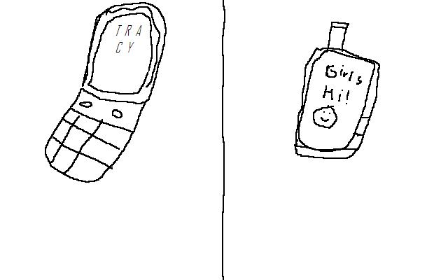
The bus stopped in front of the school. I got out and raced Abby and Stacy to the building. Stacy won. She goes to the gym all the time. She’s in great shape. I came in second place, though.
Anyway, we walked into the school building, and went into our classroom.
And that’s practically it, until school was over.

Mission Time
Abby had already posted the notice on the school bulletin board as we walked out the door at the end of the school day. We got our bikes and Abby said, “Ride over to my house. I’ve got something to show you.”
Here’s something about Abby. Her English isn’t totally American. It’s a quarter British, which is where her mom is from. Her mom is from London. Abby looks practically nothing like her. She looks more like Mr. Bartley, which is her dad. That is why she acts more like her dad, too. But she still has some of her mom in her.
We rode down the street to Honest Abe’s house, (which is actually Abby’s house.) When we got there, Mrs. Bartley was in the backyard. She said, “Oh, hel-luh Trac-ey. Hel-luh Stay-cey. Would you liak to help with the flouwers tuday?”
I said, “No thank you.” British accent. It’s cool. Anyways, on with my story.
We followed Abby to the end of the backyard, where the fence was. My jaws dropped when I saw what was there. I looked at Stacy and saw her mouth just hanging down, too.
There, on the other side of the fence, was a big clubhouse. It was like the size of two bedrooms put together. Over the top, it said:
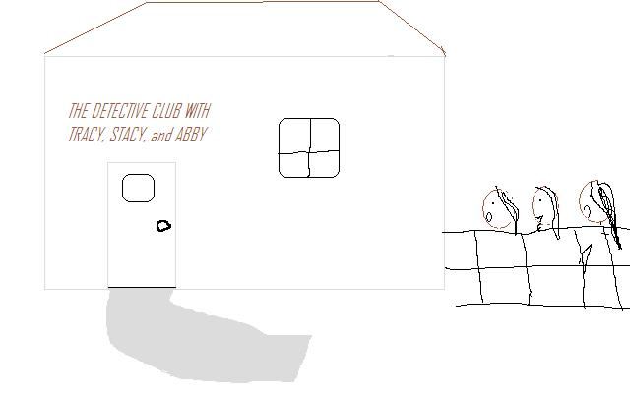
I asked, “How did you make this, Abby?”
Abby said, “Hey, it’s just the old garage. Dad’s having a new one built.” When we went inside, our jaws dropped again. On one side of the room, this is what we saw:
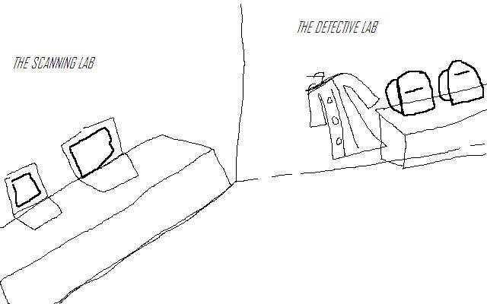
On the other side of the room, this is what I saw:
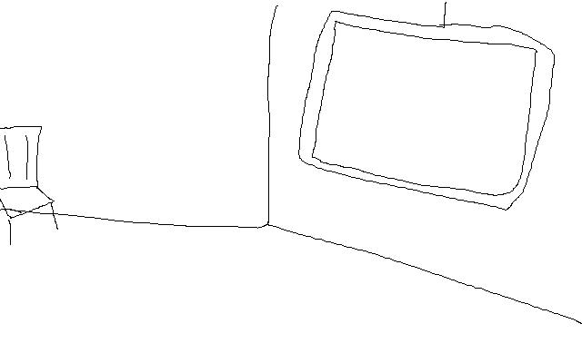
Abby said, “If we want to see some evidence bigger, we bring it to the scanning lab, take a picture of it, put the picture on the computer, and the computer will transfer it to this big screen hanging down on the other part of the room.”
I felt my pants pocket jiggling. I took my cell phone out of it. It was on vibrating. I answered it.
“Hello?”
“Hi, this is 611 Packer Hall. My daughter has lost her trophy. You need to help us. We heard that you were great detectives. Can you solve this mystery?”
I said, “Of course. You’ve called the right number. We’ll be right there.” I hung up. I told what the woman said to Abby and Stacy.
Abby said, “You and Stacy go. I’ll set this place up, and go there, too, when I’m done.” She pointed to the other side of the room. “Grab those backpacks over there. They have all the stuff you need, and typed instructions.”
I said, “Thanks, Abby.” Me and Stacy grabbed our backpacks, jumped on our bikes, and rode down to 611 Packer Hall.
I knocked on the door. “Come in,” said a voice. I opened the door. There was a woman in there, with a twelve year old girl, who was washing the dishes.
The twelve year old girl said, “Are you the detectives?”
I said, “Sure.”
The twelve year old girl said, “Mom, why did you call these little bugs?” The woman said, “Lidia Bridge, these are not bugs. Let’s see what they can do for us.”
I took a look inside my backpack. There were binoculars there. I took them out and looked around. Then, I thought I saw a trophy. I said, “Mrs. Bridge, what does the trophy look like?”
Mrs. Bridge said, “Well, let’s see. It had a star on it, it was silver, and it had ‘Archer’ over the top. I don’t know why it has that name.”
I walked over to the edge of the dining room table, and lifted it out of the corner, under the cookbook. I walked over to Lidia. She reached her hands out for it. I put my hand out in front of her. I said, “I want to do some more thinking. Let me ask you a few questions.
“Where did you win this trophy?”
Lidia stumbled on that question. Mrs. Bridge cut in. “It’s a very special trophy.”
Stacy nudged me and whispered something in my ear. I was shocked.
I didn’t mind that Lidia didn’t answer the question, “Where did you win this trophy?” because I already knew the answer. I asked her, “Are you sure this is a real trophy?”
Lidia said, “Well, not for sure.” I said, “I think I have a feeling I know what this is really all about. Follow me back to the detective lab, and I’ll show you.”
Mrs. Bridge said, “Go on, Liddy.” Lidia put on her shoes pretty grumpily, and followed us back to the club on her bike.
When we got to the club, Lidia’s mouth dropped. “Who built this?” she asked.
Abby came out of the club. “I did. Well, the inside,” she answered. She looked at Lidia. “Are you the girl who lost your trophy?”
Lidia answered, “Sure.”
I said, “I have something to scan.” Abby looked at the trophy in my hand, and nodded.
I went to the scanning lab, and took a picture of the trophy with my camera. I put the picture on the computer, and the trophy showed up big on the projector screen. I looked all around that picture. “Ah-hah!” I said. “See that? It’s not a real trophy. It a plastic container shaped like a trophy, and painted silver.
Lidia said, “Oops.”
I said, “Since you didn’t know the answer to the question, ‘Where did you win the trophy?’ I know exactly how you got it, with the help of Stacy, here.” Stacy smiled.
I said, “Didn’t you steal it from Stacy?”
Lidia stumbled.
Stacy said, “I’ve been looking for that thing forever! My mom made it for me.”
Lidia, who was only two years older than us, still had the feeling to apologize, not like Kevin, who hardy does. She mumbled a little, “So-r-ry. I didn’t know it was so special. It’s just that I haven’t won any trophies.”
I said, “It’s okay. You might win an invitation to Sue Maple Moore’s one day. I did.”
Lidia brightened up. “Really?”
“Really,” I said. “Every time there’s a spelling bee, a soccer match, a can collecting competition, school jeopardy—which will be coming next week—the prize is practically always something to do with Patricia, Pearl Watson, or Sue Maple.”
Lidia got on her bike. “Okay, thanks.” She rode away.

And then I had a feeling. When will there be a real mystery to solve?

School Jeopardy

I put down my pencil and looked up at Kevin and Robert, who were both jumping on the bed I was sitting on. “Kevin! Robert! You guys just messed me up. Go jump on your own bed. Even better, go annoy Carla! Just get out of here.”
But guess what? Kevin and Robert didn’t just disappear like they always did. They just kept on pouncing on me. They were charging from one end of the room, and charging toward my bed, tackling it like it was a football player. They were trying out for the high school football team.
I decided to just get out of the room. I went into Kevin’s room, since he was in my room. I hadn’t been in there since February, if not, more or less.
That is why, when I went in there, the light was off, and the door was closed. I walked inside and was freaked to my bones (as Abby would say, cropped to the bones of my encyclopedia). There were knights up hanging from the ceiling glowing in the dark, and there was a box in the middle of the room that looked like it had knight’s ghost in there, which, of course, couldn’t happen, because, of course, there is no such thing as ghosts, which, of course, everybody knows.
Anyways, I ran down the stairs, and bumped into the couch. I got hit in the head by something, so I stood up, got myself together, and guess what? Kevin and Robert were battling the couch this time.
I just sat near the windowsill, and just sat there. I realized I didn’t have to write in my diary anymore. I’d written all I wanted to. So, what I did was, I rode my bike right over to Stacy’s house. My parents let me ride my bike anywhere I want now, because, of course, who wouldn’t let a ten year old do that?
I knocked right up on the door. And guess who opened it? Mr. Archer. “Hello, Little Zero,” he said.
And I said, “What’s up, Big Hero?”
And then Mr. Archer scratched his chin and said, “Is that so?”
I giggled.
Every time me and Mr. Archer see each other, he does that and I do this. He is the funniest person I know. And, he is not at all serious. Seriously. He doesn’t get mad at anything; he just makes it look funny. He can make anyone laugh, even Mrs. Grant, the neighbor next door, who I always face trouble to.
Mr. Archer called up the stairs, “Little Zero Number Two, some other zero is waiting for you!” He does that every time. I like his rhymes. He can probably even rhyme the word orange, which I couldn’t find a rhyme for, since I was three.
Stacy came right down, and I ran right up. She said, “Hey-ya Trace,” as always.
“Hey-ya Little Zero Number Two,” I said.
And Stacy said, “Very funny.” I giggled. She said, “I’ve been practicing for school jeopardy. And guess what? If you look on the piece of paper where they pick the people going against each other, it’s me, you, and Dunderhead Hansson. They pick people in groups of three. Fourth graders, fifth graders, and sixth graders can enter school jeopardy, FYI.”
Dunderhead Hansson is the nickname we gave to Roger Hansson, a—now sixth grade—dunderhead.
I said, “Seriously?” and then, Mr. Bartley, who was watching us, and eating a piece of turkey, said, “Dunderhead Hansson, huh? What about Meathead Hansson? This piece of turkey doesn’t have any dunder in it, you know.”
He waved the piece of turkey in front of his head.
Me and Stacy burst out giggling. I don’t think burst out laughing fits us that well.
Anyway, after finishing up a meal of giggles and laughter, Stacy turned to me and said, “Seriously.”
And I just said, “Great,” sarcastically.
BOOM! Just like that, it’s tomorrow (Friday). I was up and right out of bed, trying to remember what the capital of Portugal was. I brushed my teeth till I thought I’d sparkle like a star.
I asked Carla what the capital of Portugal was. She said, “Lisbon.”
And then I said, “Of course.” I banged my head with my fist. Of course, banging your head with your fist does N-O-T, not help you remember anything.
Then, I asked her what the capital of Mexico was. She said, “You do not know what even the capital of Mexico is?”
I said, “Of course not. Is it Rome? Or is Rome the capital of Canada?”
Carla looked at me real awkwardly. Then she said real awkwardly, “Rome is the capital of Italy, and Ottawa is the capital of Canada, and Mexico City is the capital of Mexico.”
I guessed that I looked pretty rutabaga-ish. I asked Carla, “It’s too hard to know what in the world the capital of China is, don’t you think?”
Carla said, “You’ve got me there.”
I said, “When I get older, will I know what the capital of Turkey-Men-Is-Tan?”
Carla said, “You mean Turkmenistan. I guess so.”
I sighed, “Great,” sarcastically. Carla raised her eyebrows and said, “I thought you wanted to be older and know that Ashgabat is the capital of Turkmenistan.”
I laughed and said, “But then I’d probably eat my cereal with a fork, too!”
Carla looked at her cereal-eating-utensil. “Great,” she said sarcastically, and I cracked myself up like a chick in an egg.

I walked super-duper way too much nervously with Stacy Kim Archer and Roger Albert Hansson, as we were called.
Before we were here, me and Stacy went to Stacy’s house. We learned the trick of how to make letters appear on paper with baking powder and grape juice. How you do it is, you take a piece of paper, and you put baking powder on it, and paint a message with the baking powder. Then, you get grape juice, and use a paintbrush to brush across the baking powder message. Then, BOOM! The baking powder massage shows! It said FOUR MUSKATEERS, which was supposed to be a joke, I think, because there are actually only three musketeers, and also, you don’t spell musketeers M-U-S-K-A-T-E-E-R-S, you spell it M-U-S-K-E-T-E-E-R-S, so I guess that had to be a joke.
We went to the gigantic auditorium and sat down. We were going to go up fourth of all. Abigail Hem Bartley, Cindy Hill Kidd, and Betsy Fin Maxwell were first up. Here’s how it went:

There is a gigantic screen that has lots of squares on it. The squares have numbers on it. At the top of the screen, there are lots of topics that you can choose from.
The man who asks questions said the rules, “Each of you will get a chance to pick a topic and the number of points you want if you get the question for the topic correct. Be wise, because if you do not get the answer correctly, someone will be able to steal the points from you, if they know the answer. All set? Good. Let’s begin.”
I looked at the top of the screen again. There was the dreaded topic:
CAPITALS
It wasn’t that bad, though, because there were more topics:
STATES, VEGETABLES, ANIMALS, HISTORY
Abby went first, because her name is first in alphabetical order. She chose the topic ANIMALS, for 300 points, even though she could have picked 600.
The man asked her, “Abigail, what is the fastest animal in the world?” I knew it. It was a cheetah, of course. But when
Abby answered, “Peregrine falcon,” and got it correct, I was surprised. Fine, so I didn’t know the answer, but I knew something else. I knew that I didn’t study hard enough.
Then came Betsy’s turn was next. She picked the topic STATES, and chose 400 points.
The man asked her, “What state was once part of Mexico?”
I knew that one, for real. New Mexico, of course. Betsy answered “New Mexico,” and was right, so she got her 400 points. Then came I-am-going-to-charge-for-600-points-because-I-know-everything Cindy. Even though she is my friend, she can get very show-offish.
So, as I guessed, Cindy chose CAPITALS, and charged for 600 points. She got the question—surprise surprise (it’s super hard to answer)—“What is the capital of Maine?” And Cindy-the-know-it-all-born-with-different-colored-hair-said (the correct answer), “Augusta,” with no trouble at all, because, of course, she has a huge brain.
It was Abby’s turn again. It’s going to be too long to explain everything, so here’s how it turned out:

Abby got 3100 points at the end, Betsy got 4200, and of course, Cindy got 5000.
So, after all, Cindy won that competition. Next it was Maria Anne Slick, Grace Watt Parker, and Roger’s friend, Andy Hil Kidd, Cindy’s brother, who isn’t that bad, but still . . . Andy’s middle name is Hil NOT (as Abby would say) Hill, because his middle name was actually Hill, the same middle name as Cindy, except he didn’t like it, because it was short for Hilary, in his experience, so he spells it H-I-L, even though you still pronounce it the same as H-I-L-L, and he is at least not like Herbert Crane in Pearl Watson books, but definitely not like Roger Hansson, but anyways, he is still Roger’s friend, only Roger’s best friend is Carlos Corbin, and you had better watch out for both of them, it’s even worse than Roger just by himself, of course. So that’s the longest sentence I’ve ever said, and that’s the longest explanation I’ve ever said about Andy Hil NOT (as Abby would say) Hill Kidd, but I, personally think that Hil is more like Hilary than Hill is, because Hil has only one L like Hilary, but Hill has two. So anyway, it ended up like this:
Andy got 2900 points (too bad, because Roger was whistling through his teeth for him to crack the bones off of Maria and Grace, except he got the lowest number of points at the end) Maria got 4600, and Grace got 5300 (Which is more than Cindy!).
This was going to last from morning (right now) till night. Now it was Brianna Daily Anderson (who is a girl but does more boy stuff like draw comic books and watch super hero movies (with girls in them) and even is learning to skateboard (from ROGER HANSSON, who, believe me, doesn’t mind one single bit of teaching her to skateboard, but I, personally want to learn to skateboard, so I asked him, and did you know what he did? He just said “Knock it off,” which didn’t surprise me, but so, as you can see, he minded teaching ME to skate, so I, personally do NOT get the point of him teaching Brianna how to skate but not me), Rachel Allen Watson (who is SOOO cool (not as cool as Cindy Kidd) because her last name is Watson just like Pearl Watson), and Matthew (a.k.a Matt) Lint (a sort of thing you use for some washing thing, I believe, and I personally think it is SOOO hilarious, and I would have laughed in his face if he WASN’T a close friend of Roger Hansson) White (Mrs. White is his grandmother, who used to be my neighbor, except my friend Carolina moved into where she stayed, because she moved away to California, which is quite a lot pretty much far away from Pennsylvania, where I, personally live, and I can tell Matthew is pretty sad, even though he is tough, and I am sort of sad too, because I have never heard of anyone whose grandmother moved away to California when she/he lived about as far as the state of Pennsylvania, and believe me, I personally think that having your grandmother move away is about as exciting as an overflowing toilet, but I won’t say that around Matthew, because he, personally thinks that an overflowing toilet is hilarious, and, believe me, if your grandmother moves to California when you live in Pennsylvania, that is absolutely NOT hilarious). Again, that is the longest sentence I’ve ever said, but anyways, here’s how it turned out in the end (at this point, my legs were completely totally Jell-O (which is what Roger smacks people with) because our turn would be next):
Rachel got 4500 points, Brianna got 6100 (Again, this is more than Cindy, so she isn’t that much smart, not that she says she is, but I thought that there couldn’t be any more points more than Cindy’s number of points), and Matthew got 8200 (which is the opposite of too bad, because Roger’s whistling actually (not that I’m concerned) helped him win his round).

Now, it was our turn. I got ready to stand up. The man called the names. Except guess what? They weren’t “Tracy Alan Conway, Stacy Kim Archer, and Roger Alice Hansson,” they were “Carolina Santo Grande, Carlos Corbin, and Peter Pierce.”
I looked at Stacy. She didn’t seem to notice anything. I looked at Roger. He was just looking at the stage, whistling so that Carlos and Peter would whip up Carolina, which is not very smart, because Carolina is a blast at capitals, not like Carlos, who is a blast at disgusting things, or Peter, who is a blast at bugs, who I, personally think are not that gross. Peter is okay, not that he’s not disgusting.

I nudged Stacy. She looked at me. I said, “I thought Carolina, Carlos, and Peter were up after us, Stacy.”

The Mystery of the Missing Number

Roger looked at us. He is starting to become a regular person, because he has zipped is mouth the whole time since we were here, and when he un-zipped them, he didn’t say anything annoying. But at this point, he said, “Oh, really?” Now that annoyed me.
I just said, “Really. We picked up a number from the magicians hat, and guess what? We got the number 4. So if you would work out your cerebrum, FYI is the remembering part of your brain, then you will remember that we were going up fourth of all, but instead, Carolina, Carlos, and Peter come up on stage.”
Roger said, “Okay, I get it. FYI, I don’t really think you actually want to go up on stage on account of that what you call brain of yours can’t remember a thing.” Roger is definitely not himself today, because he would have stepped on my foot or something. He is just working out like he’s a normal boy who annoys people.
Stacy said, “Tracy has a brain, Roger. You have a brain, and everyone has a brain, except their brains are much, much, much smarter than yours.” To my surprise, Roger didn’t do anything.
I held up my hands in a way that means “Quit doing that you guys.” I said, “Seriously. Just look at our number, Roger. You have it.” To my surprise, me and Stacy were actually calling Roger Roger. Also, when Roger dug inside his pocket for our number, it didn’t smell anything like fish skeletons, which it usually smells like.
We looked at our number, and I was right. There was a 4 on the small piece of paper, there was no doubt about that. Roger and Stacy and me stared at the number. Then, Roger acted like a goof and started waving his hands around in the air so he could get the man’s attention, but of course, he was so goofy, that everyone thought he was doing that to be silly.
I grabbed Roger’s waving arms and thumped him down back on his seat. I hoped he wouldn’t step on my toe, which he didn’t. I said, “Let’s be detectives.”
Stacy said, “Yeah! Like Pearl Watson! Get it?” She snuck a glance at Roger, who looked so weird, that we had to laugh.
Roger rolled his eyes and said, “It would be much easier if we just walked up that stage and tell him that the magician didn’t count our number.”
Stacy said, “He’s got a point.”
I said, “I don’t care what point you get, because you’d end up getting the weirdest and most freaky point ever. That’s why I’m going to be Pearl.”
Roger rolled his eyeballs till I could barely see them, and, believe me, he didn’t do that to say that we were crazy, he did that to make himself crazy. Finally he said, “Fine. Let’s go to the magician’s lab and get something out of that place.”
I said, “That’s not being a detective. That would be the real answer.” I snuck a glance at Stacy. She was scratching her head.
She said, “If we have number four, Carolina, Carlos, and Peter can’t have number four, too. There’s only one number four in the magician’s hat . . . right?”
I said, “Maybe.” Roger was thinking too, which he doesn’t do at all, so this is the first time I’ve ever really saw him think.
I had an idea. I said, “Let’s get out of here and go outside. I have a feeling I might see someone or something familiar there.”
Stacy nodded, and to my surprise, Roger nodded, too. It’s easy to walk right through a bunch of people without them noticing you, because they’re too busy noticing lots of other things, too.
So we walked right through the crowd. I passed Mom, Dad, Carla, and Kevin, so I knew none of them could be on this, not even Kevin. Stacy said, “Hi, Mrs. Conway, hi, Mr. Conway, hi, Carla, hi, Crazy Kevin.” I was glad she did that, because then they would think we were just getting a random drink from the water fountain or something.
When we were outside, I saw Mr. Archer’s truck. I motioned Stacy to come closer. I didn’t motion Roger to come over, because he wouldn’t like it, and he’d be too noisy. I went inside the truck with Stacy, and on the floor, we saw the word spelled wrong, MUSKATEERS. But there wasn’t a FOUR. So the hat probably did have two fours in it; one in words, one in numbers. But if Mr. Archer hadn’t been the magician, I wouldn’t have been able to figure this out.
Stacy smiled. Then, I said, “Roger went back inside. We’re up next. I know we are, because we’re the second four. Let’s get going then.” So we went back inside, and I was right. It was our turn.
The good mystery washed my mind clear. I now knew what I was supposed to know for school jeopardy. My legs no longer felt like Jell-O. So I smiled back at Stacy.

School Jeopardy (again)
I went up on stage, planning not to mention a single thing about the two number fours. Since R, S, and T are right next to each other in the alphabet, Roger went first. He chose the topic ANIMALS for 500 points.
The question was, “What is the biggest animal on earth that--” Someone rang the buzzer.
And that someone was me. I said, “Blue whale.”
The man said, “More specific, please. Anyone else?” I rang my buzzer again.
“Female blue whale.” The man looked at the answer.
“Wow, Tracy! You stole Roger’s number of points, and I didn’t even finish the question! To make more sense, the whole question was ‘What is the biggest animal on earth that weighed the heaviest, so far?’ That was good, Tracy.”
I looked into the crowd watching. Even though there were a million people—just about—and it was pretty noisy, I could hear Kevin, Carla, and Abby—at least Kevin and Carla, because Abby is still learning—whistling to me, and I could picture them right there.
Roger cocked his head like a real confused chicken. Except for the chicken part, it’s all true. But he didn’t say anything, because, he knew he lost his turn.
Then, it was Stacy’s turn next. She chose the topic VEGETABLES for 600 points. I knew I couldn’t steal any points from her because I’m not at all an expert of vegetables.
The man asked, “True or false? Vegetables do not have seeds.”
Stacy said, “True!”
And the man said, “Correct!”
Next it was my turn. I chose the topic CAPITALS, even though I knew I was going to get it wrong, but I still had a chance, because there was a chance to get 1000 points by answering a question correctly on the CAPITALS topic. So the question was, “What is the capital of Russia?”
Now THAT was a tough one, but I had studied hard, and now my brain was washed with a million memories, so just like that, I said, “Moscow,” except for I hope I pronounced it right, but anyway, the person said,
“Correct! You’ve just got 1000 points!” The crowd clapped.
It was Roger’s turn again. He got the answer to the question right this time, which rarely happens. Stacy got her next question right, and so did I.
It was the same the next time. But on the fourth round, Roger got one wrong. In the fifth round, all of us got the answer to the question wrong.
The score was: Roger: 2800 Stacy: 3400 Me: 3300. So anyway, there was the bonus buzzer question. You get 2000 points if you get this question right.
The big question was (it doesn’t have anything to do with any of the topics) “What is the definition of sarcophagus?” Stacy buzzed her buzzer at the same time as I did. So in this case, we had to write our answers down on a piece of paper, and the one who got the answer right, got the 2000 points. I wrote down:

A mummy coffin thingy

Because a sarcophagus IS a mummy coffin thingy, if you ask me, or anyone else who even knows what a sarcophagus is.
After we were done writing, we showed what we wrote to the person man, and Stacy had written a case which you put a mummy in, so we both got 2000 points, but Stacy won, though, by 100 points.
So the final scores were: Roger: 2800 (still the same as before) Stacy: 5400 Me: 5300. Anyway, it was a great game.
I couldn’t wait to tell Abby what mystery I just solved, the one about the two fours.

Because guess what? I’d just become Tracy Conway, Real Detective.
The End.

Psst… Visit the Tracy A. Conway website for:
- More books!
- More contests-maybe you could get your name in the book next!
- Meet your favorite characters!
- Take the quiz!
- Send a text message to Tracy!
- And way more!
All on www.barakahshakoor.wix.com/tracyaconway.

If you are reading this book on the computer, you may buy the book when it gets published. Watch out for the announcement on the link above, or, search for it on www.lulu.com.
Thanks for reading!

Check it out! There’s the first
Official Tracy A. Conway, Volume 1, Books 1-3 Book! Visit www.lulu.com to buy!
