My 2011 SUMMER JOURNAL by Tracy A.

Okay, so I am 12 years old now. Here’s a picture of me at summer camp:


I am almost an actual teenager, which means I will be in actual high school in an actual 2 years. Brrr… Anyway, here’s the breaking news. Kevin was making a grilled cheese sandwich but he forgot to put two pieces of bread on it and the cheese ended up on the bottom and got stuck to our brand-new pan which is now not so brand new so we have to get another brand new one and Kevin is not allowed to make any more grilled cheese sandwiches until he’s 20, which will be in another 5 years.
Oh yeah, and my big sister, Carla, got a drivers’ license. She is 16 now, and she actually learned to drive when she was 14. Kevin has just got the hang of driving, and he is 15.
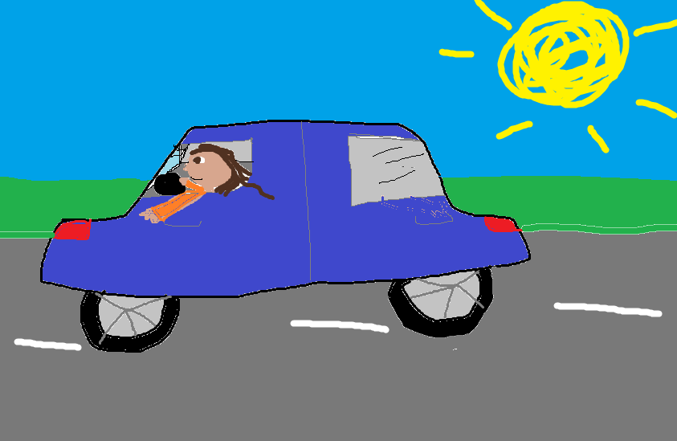
She basically drives with one hand and sticks the other one out the window. I keep telling her not to do that, because one time her elbow accidentally clicked the window button, and her arm was almost a goner.

We also went to New York, and took sixteen quajillion pictures. Here’s a couple of them:

Well, the rest of the summer included soccer games, basketball games, things like that. Now the football games are starting. All I know is that Kevin will want Greenbay to win whenever they play, Dad will want Pittsburg to win, and Mom, Carla and me will want Dallas to win. That’s pretty much it.

CONGRATULATIONS! You have earned the 2nd Tracy A. Conway badge and club sticker! Print them out, stick a safety pin on it, and you’ll have your own actual badge!


